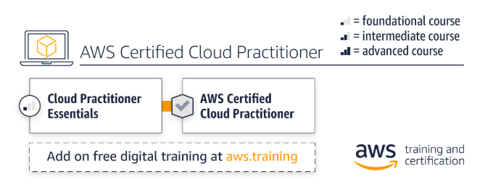

|  |  |  |  |
| --- | --- | --- | --- |
| Training | Type | Duration | Register |
| AWS Cloud Practitioner Essentials | Digital | 6 hours | [Take the digital class](https://www.aws.training/learningobject/curriculum?id=16357&src=path-cp) |